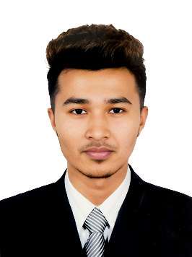**CURRICULUM VITAE**

**Of SHEIKH FAHAD**

Cell: +88 01928101083

NHA Garden City Mohammadpur, Dhaka-1216.

E-mail: [sheikhfahadcse@gmail.com](mailto:sheikhfahadcse@gmail.com)

GitHub: [www.github.com/sheikh-fahad](http://www.github.com/sheikh-fahad)

**Career objective**

A motivated, adaptable and responsible graduate actively seeking a position as Management Trainee with well-established company in which my educational background and special talents can enhance organization growth.

**Project**

* Personal Portfolio - HTML, CSS, BOOTSTARP, JAVASCRIPT, PHP.
* Google Translator – PYTHON, Library (Google trans).
* Image Transformation – PYTHON.

**Achievement**

* Three software projects were successfully completed.
* Two YouTube Channel.

**Professional Training**

* Full website development – 2022 Pytech Digital.
* Php with Laravel – 2023 pencil Box.

**Academic Qualification**

* **Bachelor of Science (BSc)**
  + Institution : Bangladesh University
  + Department : Computer Science Engineer
  + Result : 3.48
  + Session : 2020
* **H.S.C (Higher School Certificate)**
  + Institution : Dhaka Udyan Government College
  + Board : Dhaka
  + Group : Science
  + Result : 3.93
  + Passing Year : 2019
* **S.S.C (Secondary School Certificate)**
  + Institution : Government Science School
  + Board : Dhaka
  + Group : Science
  + Result : 4.27
  + Passing Year : 2017

**Computer Ability:**

* Programing Languages (HTML, CSS, BOOTSTRAP, PYTHON)
* Adobe Application (Adobe Photoshop, Adobe premiere pro, Adobe InDesign, Adobe Audition, Adobe Illustrator, Adobe Podcast)
* Office Application (MS Word, Excel, Power point, Access)

**Interpersonal Skills:**

* Ability to work under pressure
* Communication skills
* Critical thinking
* Multitasking
* Time Management

**Language Proficiency:**

* Have good communication skill in English.
* Have good communication skill in Hindi and Urdu.
* Well capable of communicating with people in Bangla.

**Personal Details**

Father`s Name : Md. Serajul Islam

Mother`s Name : Jesmin Akther

Date of Birth : 25 September 2000

Religion : Islam

Nationality : Bangladesh

Blood Group : O+

**Declaration**

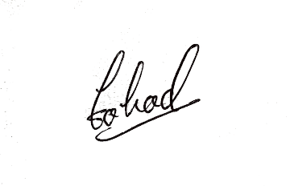I do here by certify that, the above statement is true. I am ready to show all kinds of supporting document state here at any time.

______________________